EARLY BOOKING DISCOUNT 20 % !
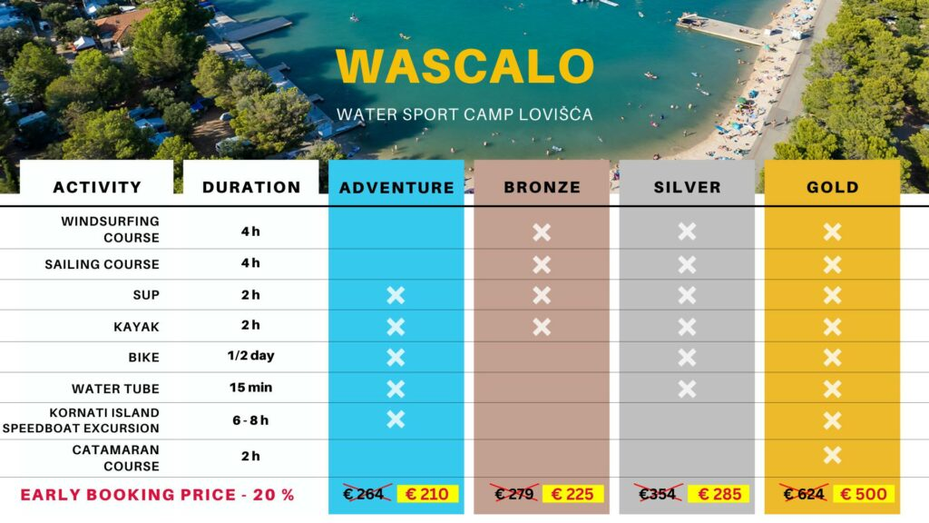

Book your spot on WASCALO’s website and get a 20% discount for early booking!
* additional 10% discount to all the Camp Jezera Lovišća guests !

